**Git**

**Tutorial 1 (**[**https://www.youtube.com/watch?v=SWYqp7iY_Tc&list=PLepJyg1eWJjq1tfgH3lAi_0LHylgVZ9u4**](https://www.youtube.com/watch?v=SWYqp7iY_Tc&list=PLepJyg1eWJjq1tfgH3lAi_0LHylgVZ9u4) **)**

* 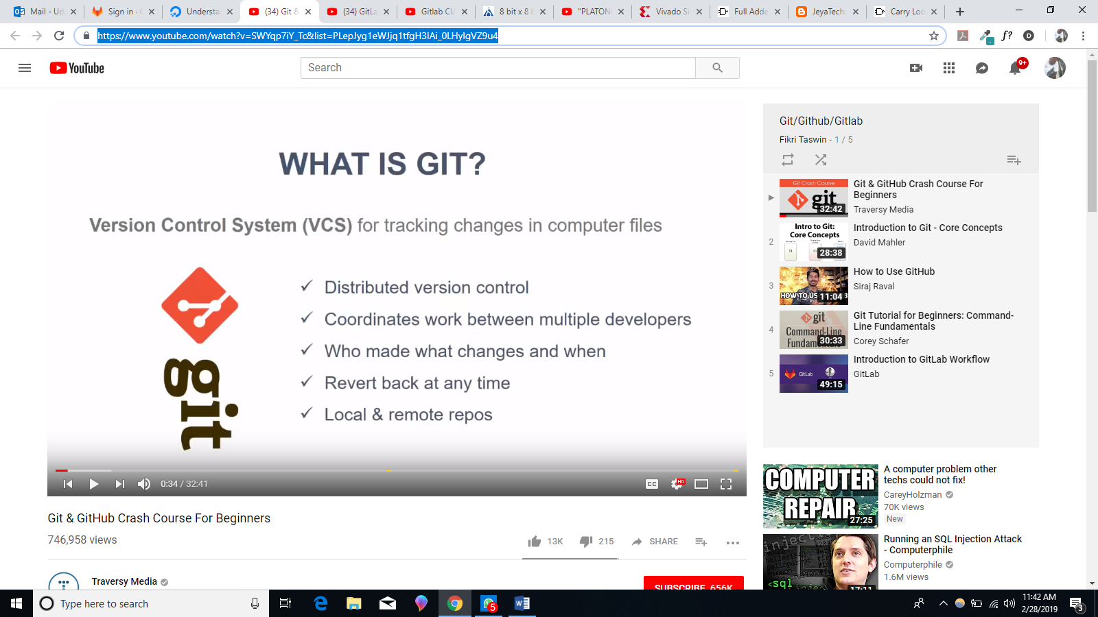
* 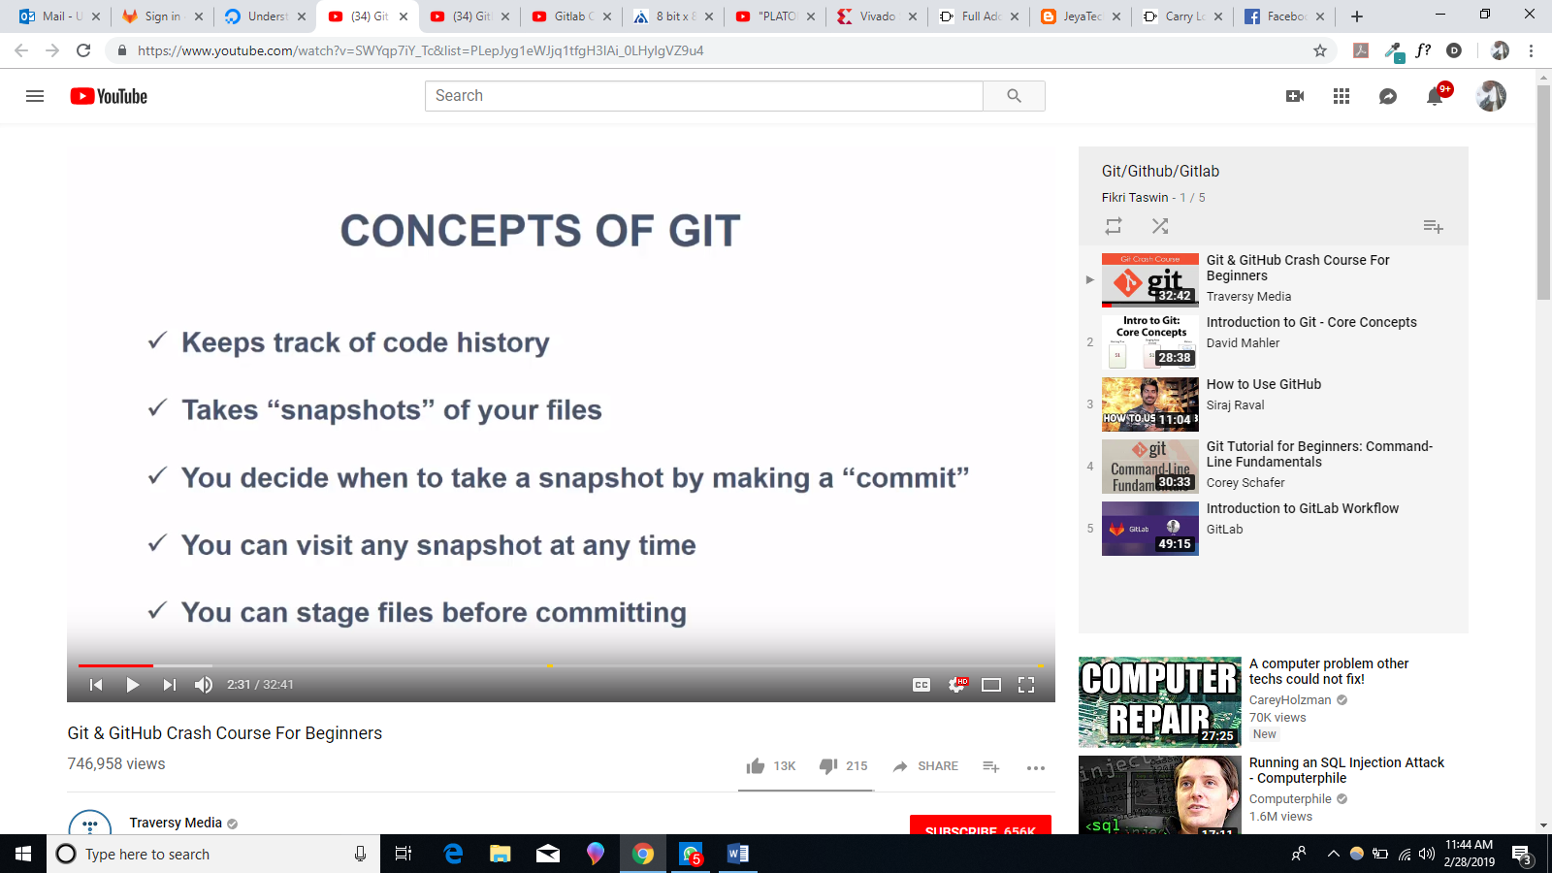
* 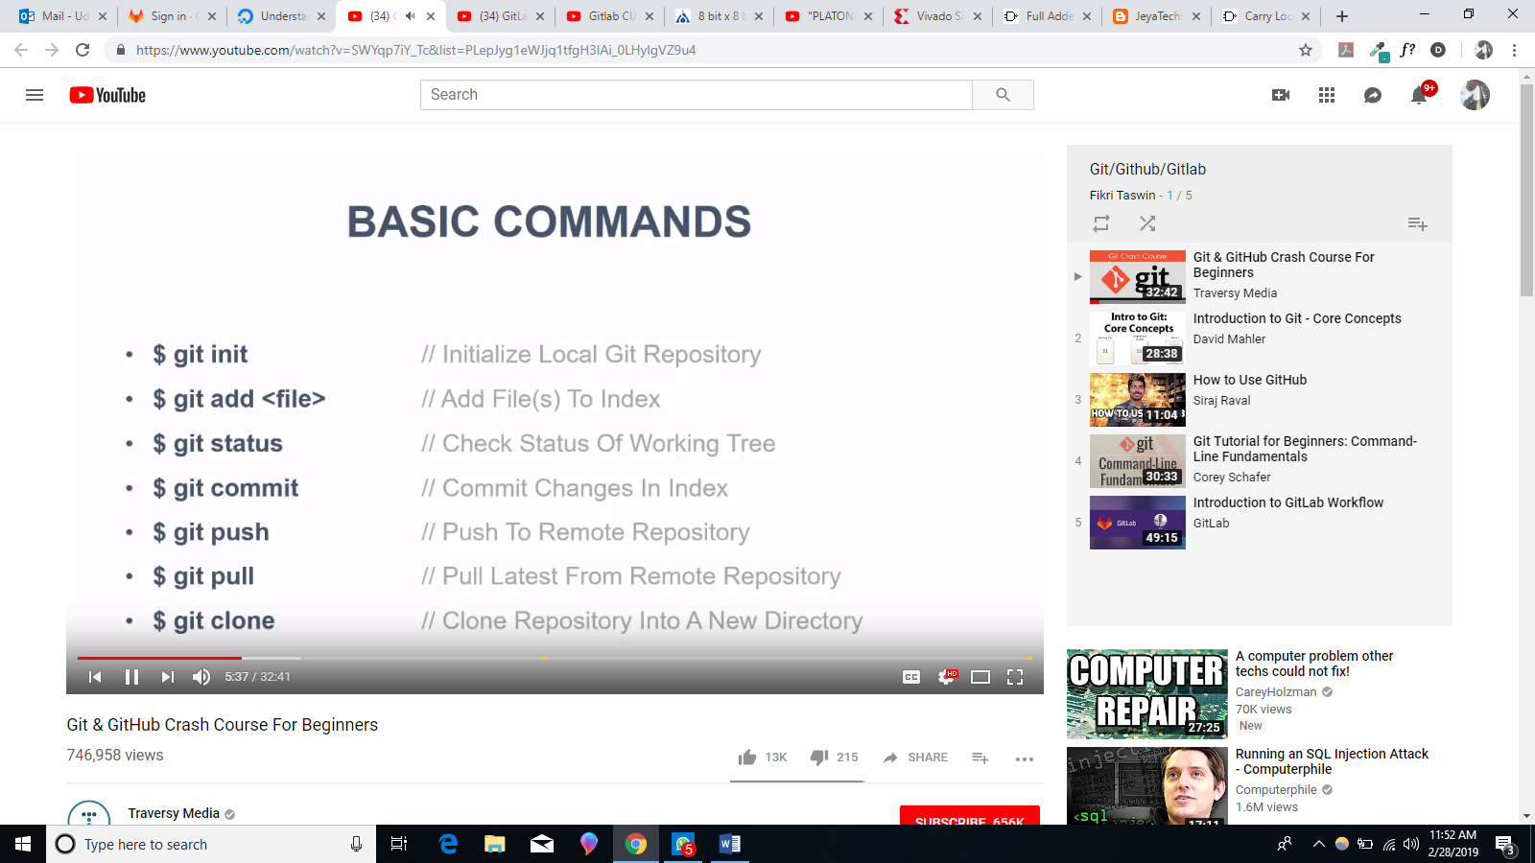
* 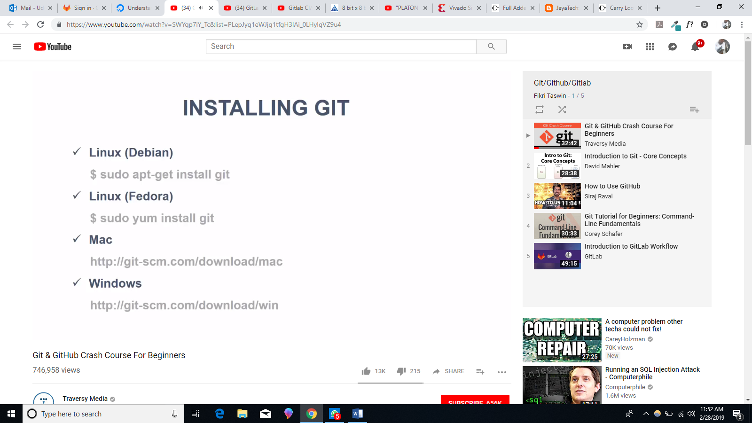
* 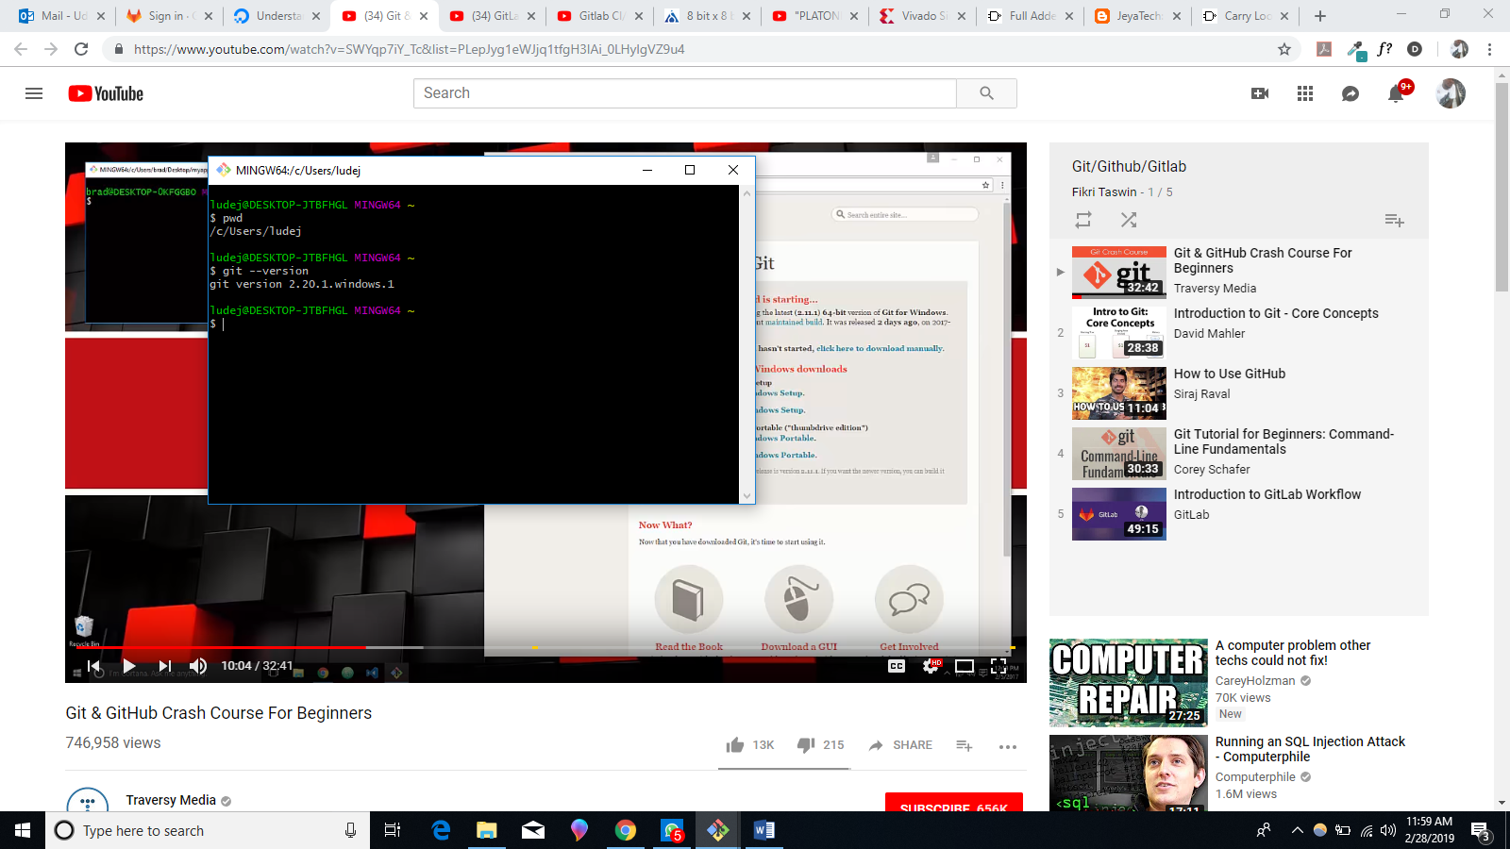
* 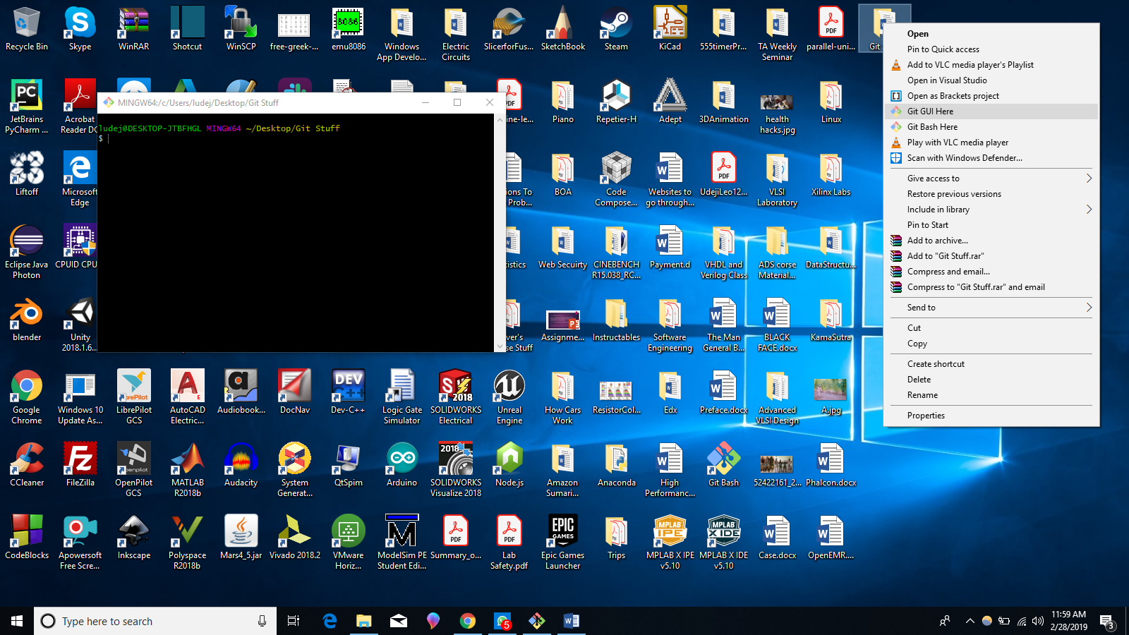
* By holding CTRL button and scrolling the mouse you can control the size of the git command line font. (I noticed that you can also use this to change your overall windows font size).
* 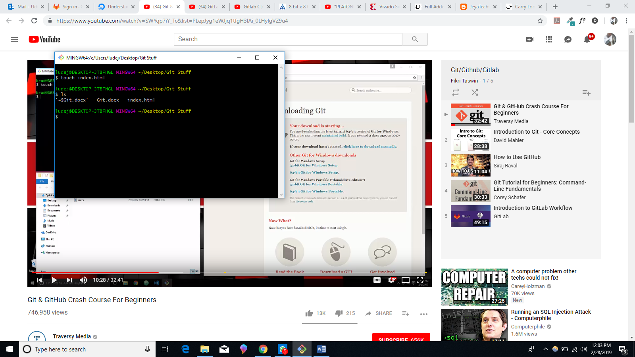
* 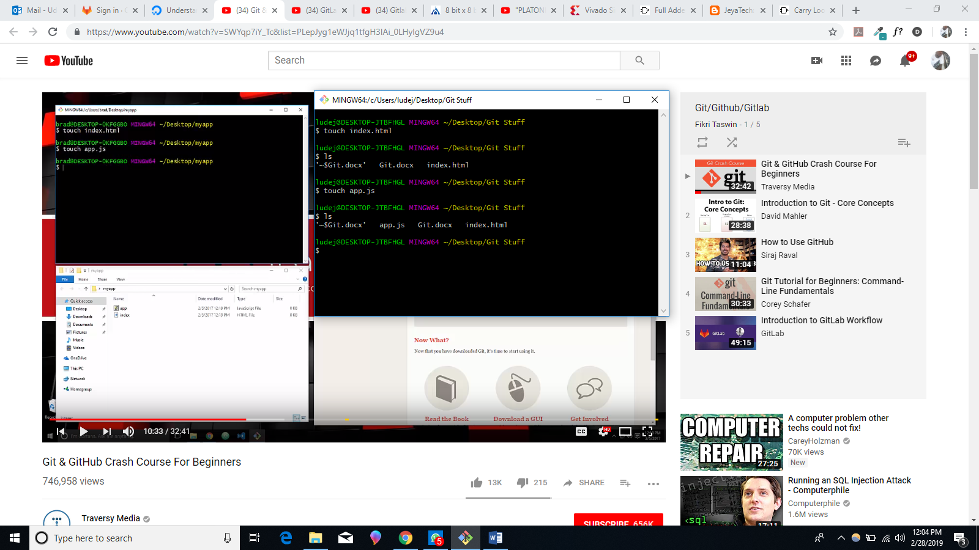
* We checked “hidden items” under View to make hidden items visible.
* 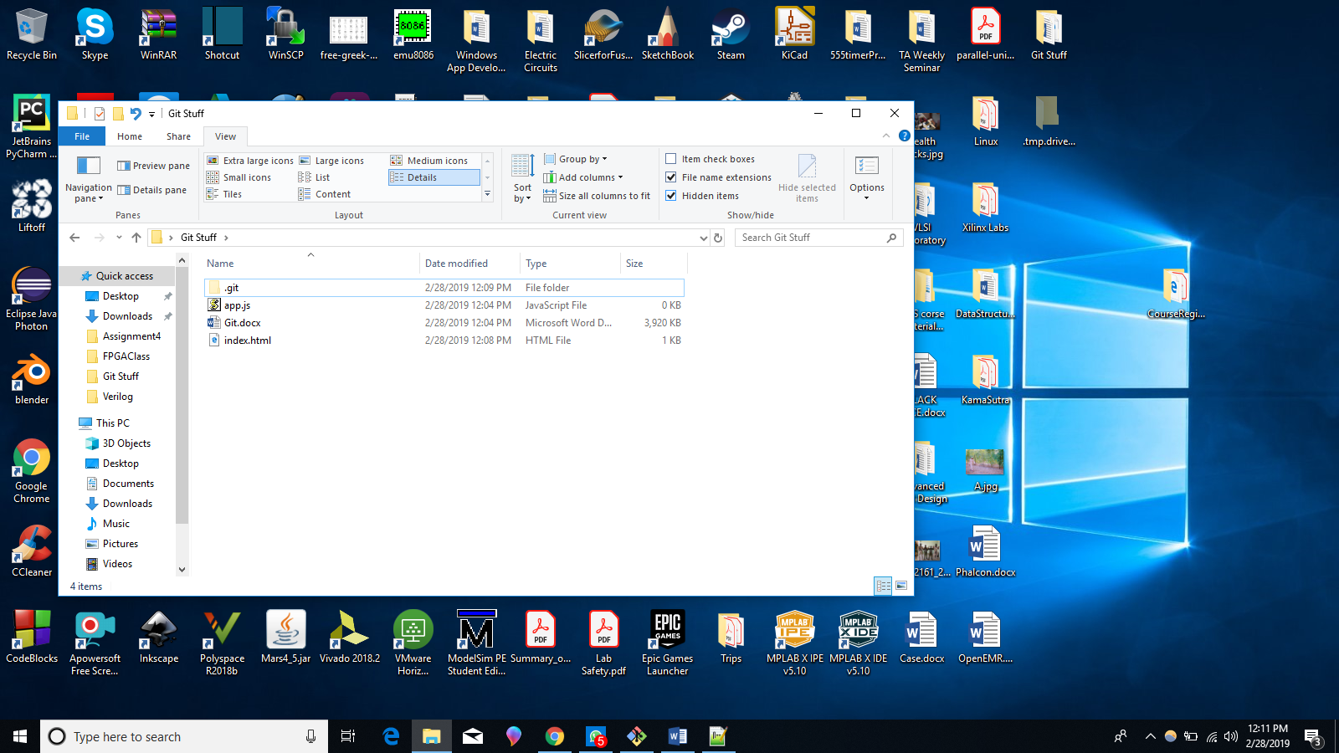
* 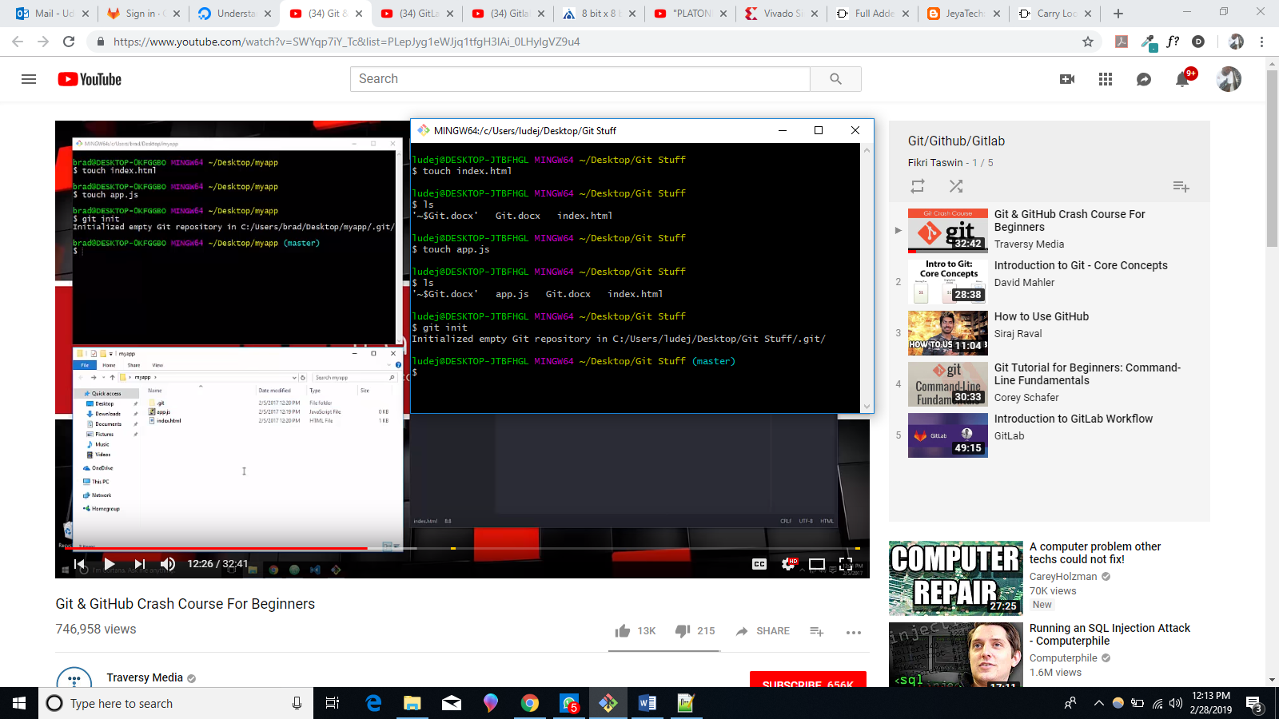
* Now that we have initialized this folder as a git repository we can start to use git commands.
* 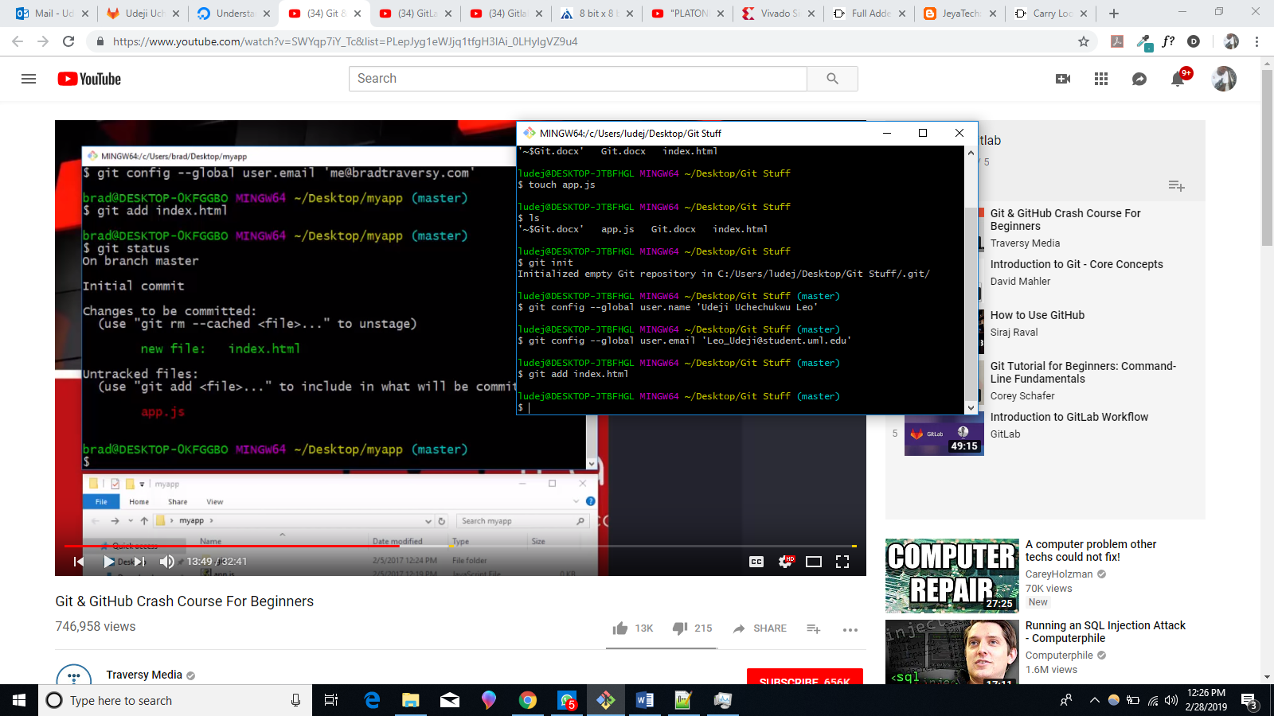
* 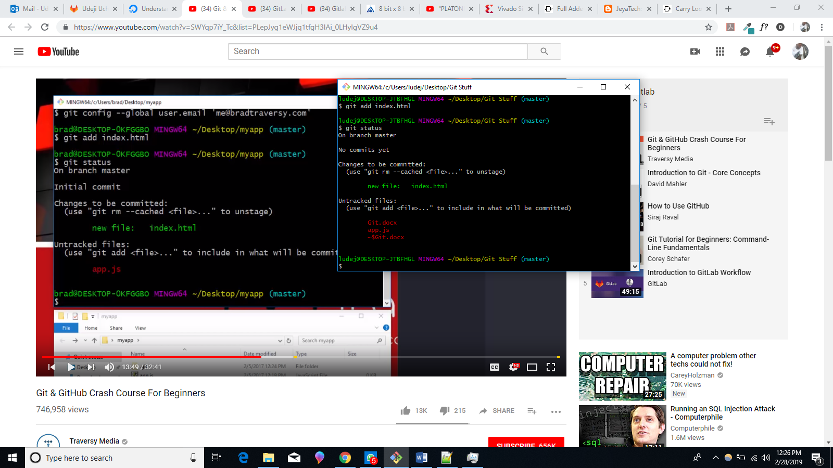
* 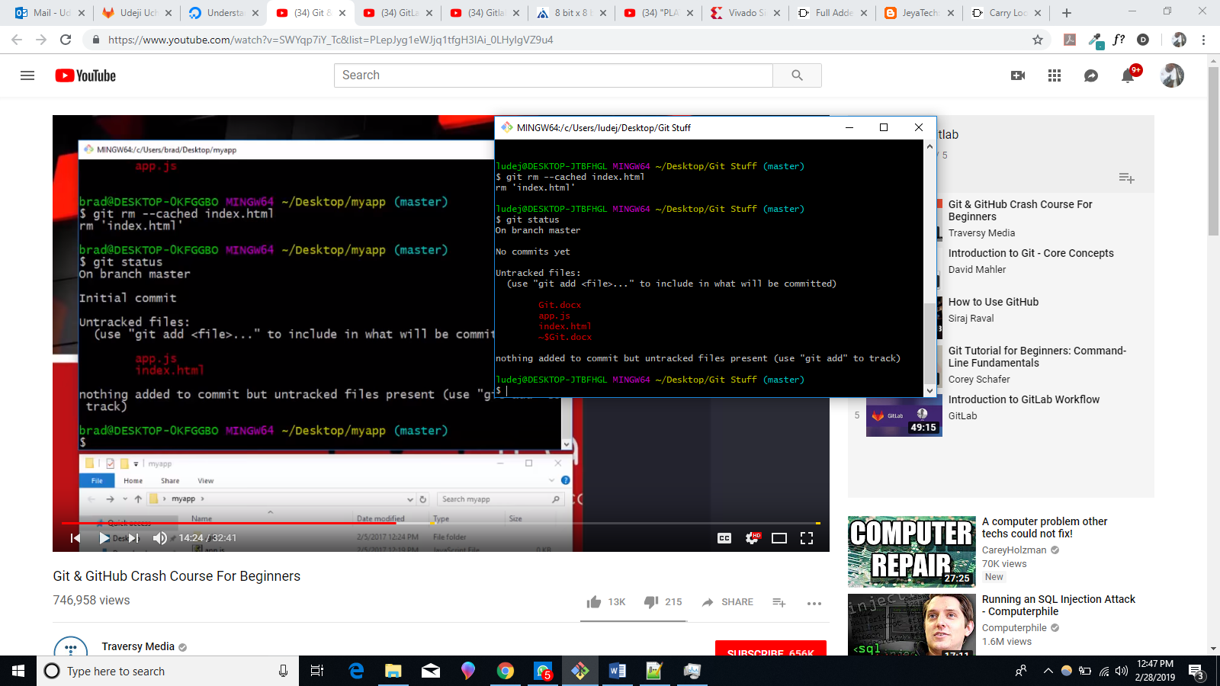
* **“git add *.html”** adds any html file to the staging area as shown below:
* 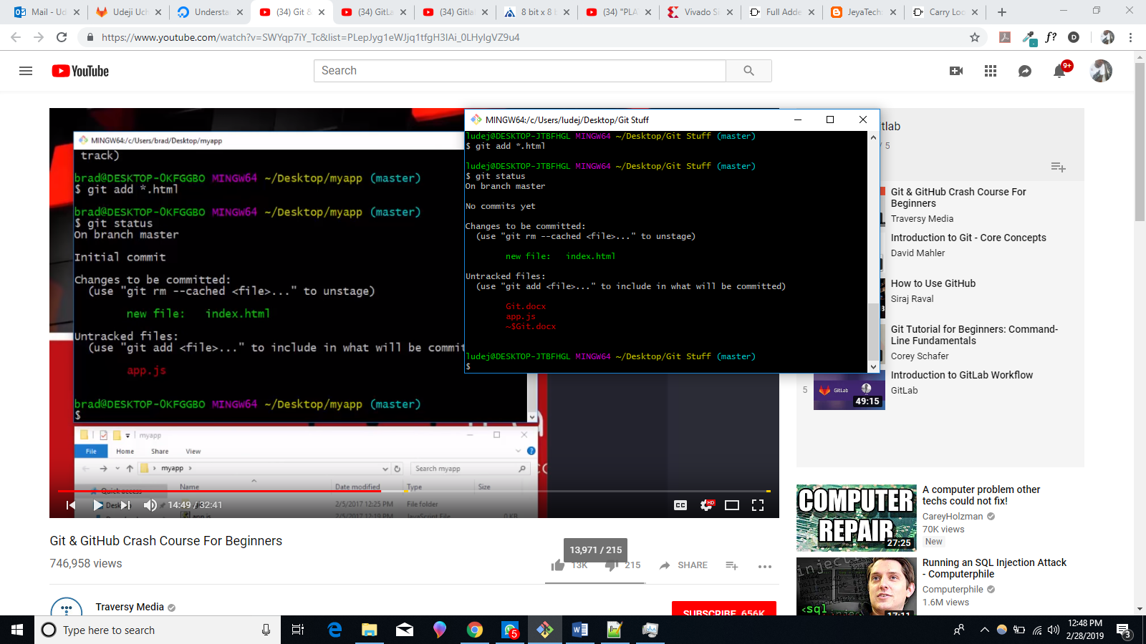
* **“git add . ”** basically adds everything in your folder.
* 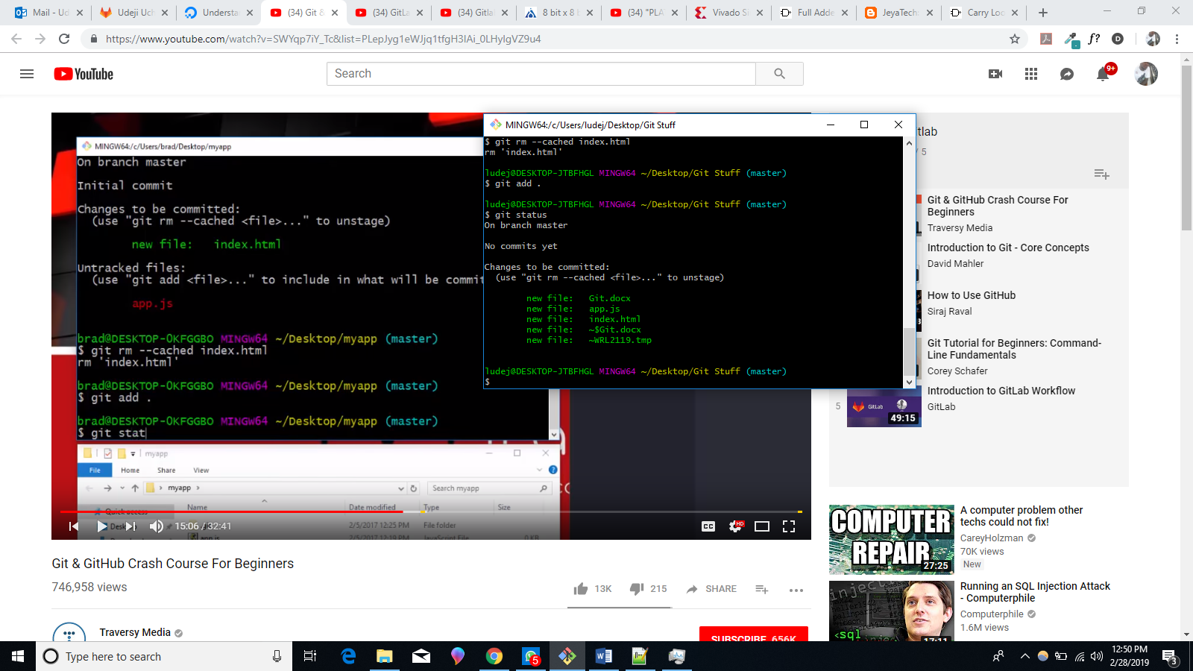
* If you edit any of the files and enter “git status” you will be notified of any changes that has been made.
* 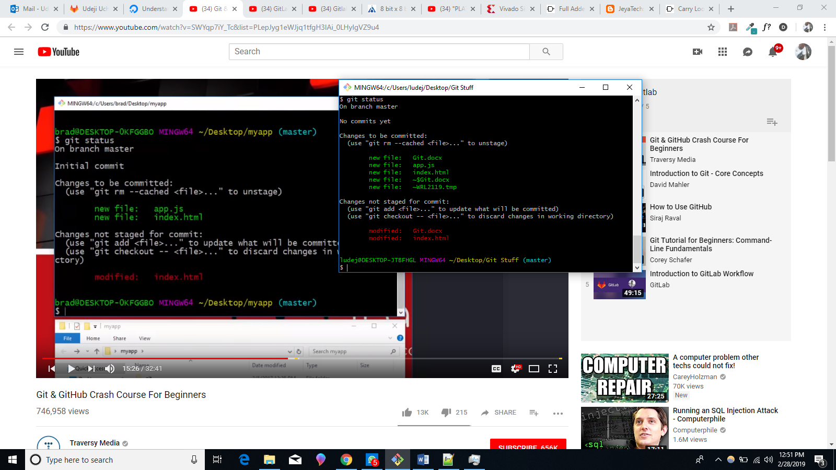
* **From the picture above** notice that “git checkout --” or “git add” command can be used to either discard or update the changes that has been made.